- when you launch the Billing details page for existing customer , currently on the landing page, Billing address list applet is being shown, need to hide it and show only Billing Address form applet (Hide entire Captured Billing addresses list applet section) and also details are missing in Billing address form applet, please check the pr file
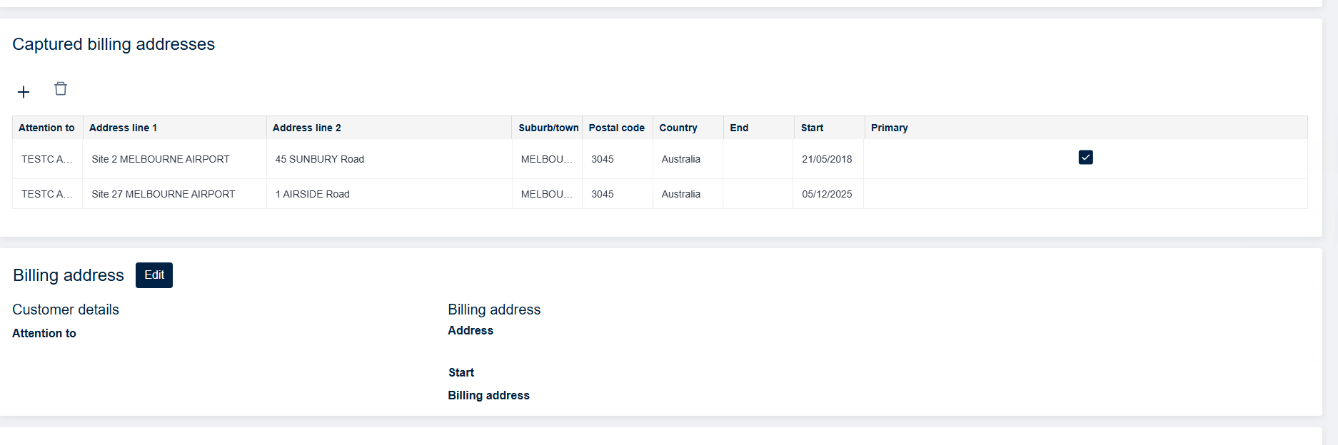

And also check the figma design

- After clicking on Edit button, it should show list applet at the top and form applet at the bottom and user should be able to update the existing address in form applet and click on list applet then it should show address has been updated successfully as per figma
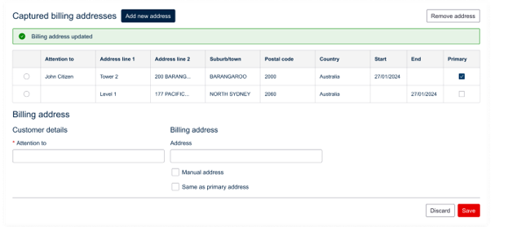

- For new record and delete record, it should show the caption as per figma

- When user click on Manual address checkbox, the manuall address form applet should open in Edit mode, currently its open it Base mode, please check if open UI can open the applet in Edit mode

